

­

Equality, Diversity and Inclusion

Annual Report

**2016**

2016 EDI Annual Report

1

# 2016 EDI Annual Report

2

|  |  |
| --- | --- |
| Contents | Page |
| 1. Introduction | 5 |
| 2. Equality Policy | 5 |
| 3. Legislative Compliance | 5 |
| 4. Equality Objectives 2016-2020 | 5-6 |
| 5. Performance against the Equality Objectives in 2016 | 6-7 |
| 6. Ofsted | 8 |
| 7. The EDI Group at Central | 9 |
| 8. Staffing Profile | 10-12 |
| 9. Student Profile | 13-16 |
| 10. EDI Actions in 2016 | 17-20 |
| i. Policy Development | 17 |
| ii. Promoting EDI | 17 |
| iii. Engaging Student | 17 |
| iv. Training and Development | 18-20 |
| v. Service Monitoring | 20 |
| 11. Incidences of Bullying and Harassment | 20 |
|  | |
| Appendix A | |
| Guidance on the Public Sector Equality Duty | 21 |

2016 EDI Annual Report

3

2016 EDI Annual Report

4

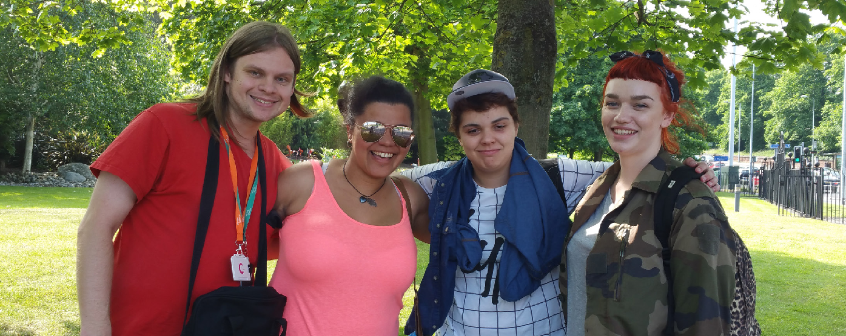

1. Introduction

This Annual Report provides a review of Equality, Diversity and Inclusion (EDI) at both Central College Nottingham and New College Nottingham (ncn) in 2016, in preparation for the new merged organisation, Nottingham College, early in 2017.

As part of the merger process, work to align the approach to EDI commenced in 2016. Both colleges are committed to delivering an inclusive environment for all students and staff and to embedding equality and diversity within all aspects of their business and academic functions.

The Annual Report includes equality information on the colleges’ student and staff populations and details the active commitment of the colleges to continually meet the Public Sector Equality Duty. The report identifies progress, and challenges, in continuing to provide a supportive environment for all members of the college community through a review of EDI actions, the work of the EDI group, and an analysis of equality information relating to staff and students.

1. Equality Policy

A single Equality, Diversity and Inclusion policy was drafted for Nottingham College and was ratified at the end of 2016. As such, for much of the year both colleges continued to work to their pre-existing policies. New College Nottingham’s policy was reviewed in January 2016 with no substantive changes made. Central’s change of the college’s equality statement, as part of their policy review, was approved by the Corporation in February 2016: *Central College Nottingham is positively committed to creating an environment which is free from discrimination, and where there is mutual respect and equality for all.*

1. Legislative Compliance

The colleges continue to meet their Public Sector Equality Duty responsibilities (Appendix A). The colleges’ equality policies and the new merged single policy are legally compliant and enable each organisation to respond to the statutory duties set out in the Equality Act 2010 and the Public Sector Equality Duty 2011- to advance equality of opportunity, eliminate discrimination and foster good relations.

To meet the specific duties of the Public Sector Equality Duty the colleges’ equality objectives were revised at the start of 2016 and new joint objectives for 2016-2020 were published in April 2016.

Legal compliance is supported by the provision of information, advice and guidance, and coaching and training to all stakeholders. The continued completion of Equality Analyses for all policies and changes in service provisions, including those associated with the planned college merger, ensures that staff carefully consider how existing and proposed policies or decisions impact on equality.

1. Equality Objectives (published April 2016)

Both colleges set joint equality objectives for 2016-2020, making this one of the first co college collaboration pieces. The objectives comply with legislative Public Sector Equality Duties and provide performance indicators for all college operations. Objectives are to challenge discrimination and disadvantage; raise standards; and advance aspirations of all of our stakeholders.

# 2016 EDI Annual Report

5

College objectives are to:

* + Raise the achievement and success levels of different groups of students and work towards eliminating the gap in achievement between students with protected characteristics and those without
  + Ensure all teaching, learning and assessment promotes, advances and celebrates diversity and British Values
  + Recruit, support and develop a diverse staff population which reflects and meets the needs of students and the community the college serves
  + Engage with students and stakeholders to improve student satisfaction for all groups and enhance the student experience
  + Support and enable access to learning for a diverse range of students

At Central College Nottingham the EDI Group leads on achieving these objectives through regular monitoring of specific targets set in a comprehensive EDI Action Plan and EDI Strategy which outlines forthcoming activities, timescales and responsibilities. At New College Nottingham the Head of Human Resources led on achieving objectives with the wide support of academic and business heads of service.

Previous objectives, 2012-2016, were largely met with details noted in Section 5. These wholly reflect the current objectives and additionally included:

* + Developing teaching resources to embed EDI into the curriculum
  + Engaging staff and students in EDI activities
  + Develop a range of training resources and materials to update the understanding of EDI concepts for all staff
  + 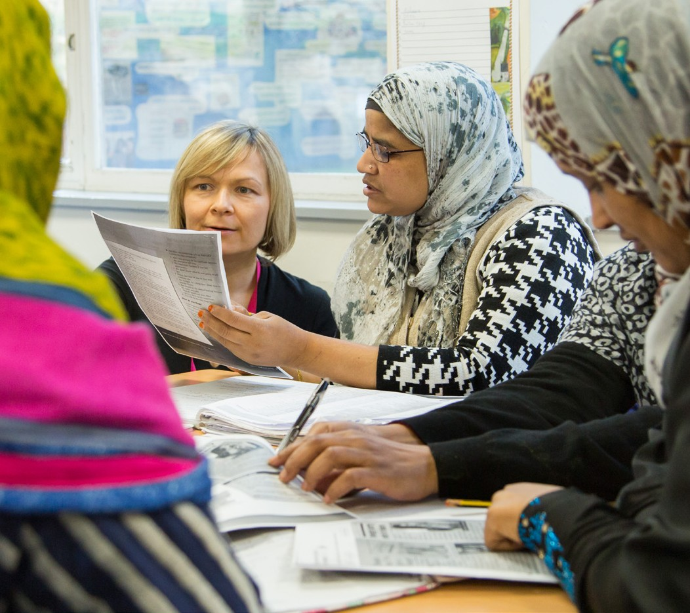Ensure all staff understand their own, and the College’s legislative, duties

# 2016 EDI Annual Report

1. Performance against the Equality Objectives in 2016

The objectives for 2016 were largely met, with any outstanding and continuing targets noted in the colleges’ 4 year action plan (April 2016-March 2020).

The following summary highlights the activities which have contributed to achieving these objectives:

* Effective analysis of student data has enabled EDI student retention and achievement trends and concerns to be identified, followed up, and actions put in place to drive improvement. This has contributed towards achievement gaps narrowing or closing
* Effective analysis of academic teams’ Self-Assessment Reports (SARs), equality data, and inspection and observation feedback which identify areas in need of training and support. Areas for development are integrated in departmental action plans
* The delivery of high quality face to face training to groups of staff, successfully raising skills and knowledge levels as evidenced by positive evaluation of training
* Effective support to curriculum teams to engage students more fully on equality issues, resulting in improved practices in a number of curriculum areas. 2015/2016 saw a large increase in numbers of students benefiting from EDI sessions (618 students representing a 33% increase from 2015). The delivery of bespoke training to groups

of students has broadened knowledge and extended experience with positive evaluation and feedback

* The development and utilisation of an EDI Toolkit for curriculum teams at Central, supporting teaching and learning staff to further improve the integration of EDI in the learning environment. Launched in September

2015, 5659 hits to the toolkit were recorded by the end of the academic year. Most popular courses have been the Promoting British Values and Managing Prejudice modules

* Improved practices in fully integrating EDI in a number of curriculum areas has been evidenced by the increased visibility of the promotion of diversity, a reduction in the number of missed opportunities and a tangible culture of respect seen in formal observations and learning walks. At ncn it was reported that 70% of all observed sessions were positively encouraging and developing learners EDI awareness
* Effective integration of EDI in the colleges’ ER provision, specifically Apprenticeships, through a programme of learning walks, and assessor support and training
* Effective support to College partners and sub-contractors on EDI matters as and when required
* Improved physical accessibility to environments, for example ensuring a community based location is accessible for a disabled student or the refurbishment of refectories to provide height adjustable tables

# 6

* High quality and accessible advice and guidance on EDI issues delivered through a range of channels including the use of on-line resources:
  + 125 enquiries from staff and students at Central in 15/16 which required a response in the form of

information, advice, guidance or active support were noted. Examples include guidance on transgendered students, access to classrooms and toilets, prayer times and facilities, reasonable adjustments for people with disabilities, equality analyses, bullying and grievance processes; and active support with student behaviour

* + one to one coaching and support to improve practices for individual teaching staff
* Effective links established with the observation team to ensure continuity with advice on EDI practice with the EDI team involved in learning walks and shadowing observations. An evaluation of lesson observation reports at Central effectively identifies good practice to

be shared as well as flags any training or support needs for curriculum areas (See section 10. iv, page 19). At ncn teaching staff were invited to demonstrate their progress in year with specific issues in teaching and learning, and 72% demonstrated positive impact on raising awareness of EDI issues in their teaching and learning

* Positive action strategies employed to address areas of underrepresentation: for example women into IT, Computing, Construction; Black and Ethnic Minority (BAME) groups and people with disabilities/difficulties

into apprenticeships; for example through a review of the course offer, design and delivery or through promotional materials and the use of positive role models which challenge stereotypes

* Good levels of engagement with students on EDI matters outside of the classroom through the student union, student forums, the EDI group and activities and events. This has resulted in students improving their understanding of EDI as well as developing personal and professional skills, for example with organising events
* Students engaged with stalls and activities which explored the diversity of the community they study, live and work in have made an impact on individual perceptions: *“I got to celebrate who I am and to talk to people about it to help them understand”; and “I’ve learnt to not judge a book by its cover”*
* Effective cross-curriculum working to provide opportunities for students to work with those on different courses, for example Horizons and Sport. This has proved effective in breaking down barriers, fostering relationships and increasing understanding of others
* Clear guidance on processes around e.g. prayer times, supporting trans students, reflection room usage and women who wear full face veils
* Rigorous monitoring of incidences of bullying and harassment and discrimination through the college complaints processes. (See Section 11)

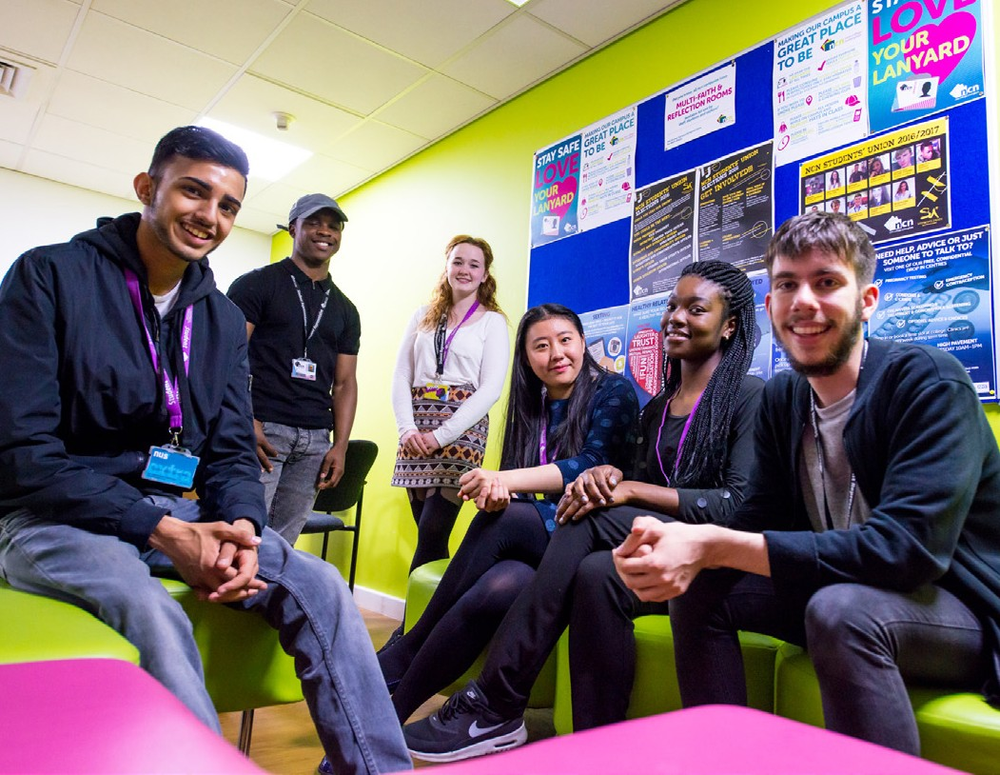

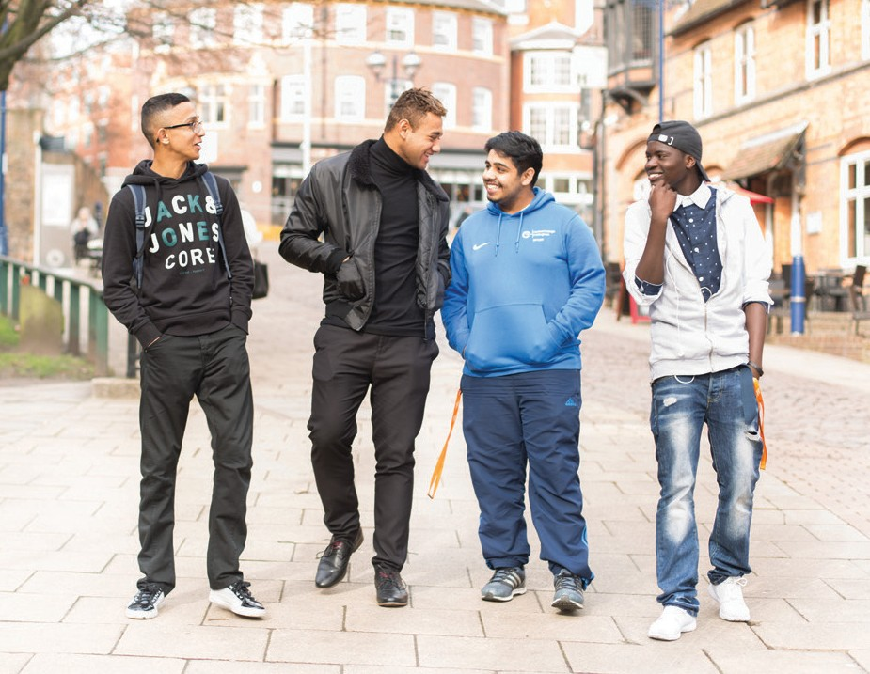



# 2016 EDI Annual Report

7

1. Ofsted

The Ofsted inspection in December 2015 for ncn and in January 2016 for Central College demonstrated that both colleges

are promoting equality and diversity effectively. There was particular positive recognition for:

* Respectful and welcoming environments
  + *“Learners treat each other, their teachers and other staff with respect”* (ncn)
  + *“An overall culture of respect and tolerance permeates the college. Managers and staff take every opportunity to celebrate diversity. Consequently, learners display a good understanding of different faiths and cultures and are highly respectful of each other”* (Central)
* The wide range of support that helps learners and apprentices overcome any difficulties they may have
  + *“Staff liaise very effectively with schools, parents and carers, and other providers and agencies to plan programmes for learners with high-level and often very complex needs”* (ncn)
* Individualised and flexible programmes
  + “*Learners from the most vulnerable groups, such as looked-after children and those for whom there are safeguarding concerns, are cared for well and as a result they remain in learning and achieve qualifications at a similar rate to other learners”* (Central)
* Students’ understanding of equality and diversity
  + *“The effective promotion of equality and diversity through a well organised programme of events, exhibitions and celebratory activities, and by working successfully with local organisations, for example the interfaith council”* (ncn)
  + *“Learners’ cultural horizons, cultural awareness and understanding of their responsibilities as citizens are expanded through a very broad range of enrichment activities, some of which are instigated and led by learners”* (Central)
  + *“A recent imaginative project saw learners research and report on the reasons for low*

*achievement by some groups of learners, and make recommendations that the college adopted to remedy the performance shortfall.”* (ncn)

* The effective facilitation of the British values agenda

- “Teachers integrate well the themes of British values and the tutorial system helps learners to develop their understanding of the risks of extremism and radicalisation” (Central)

# 2016 EDI Annual Report

* The effective monitoring of data to identify and reduce differences in the performance of various groups of learners.
  + *“Disabled learners, and those with learning difficulties, perform better than other learners; learners with high needs succeed particularly well”* (ncn)
  + *“Data show few gaps in the attainment of specific groups of learners, such as those from minority ethnic backgrounds. Managers are aware of where gaps do exist and, in almost all cases, implement successful strategies to close them”* (Central)

Both ncn and Central College Nottingham received ‘Good’ grades. Areas of development for both colleges had been identified prior to inspection, that is: a consistent approach “for all teachers to regularly use opportunities to develop learners’ further awareness of matters relating to diversity in lessons” and “improving the quality of teaching to eliminate the small minority of lessons where the individual needs of

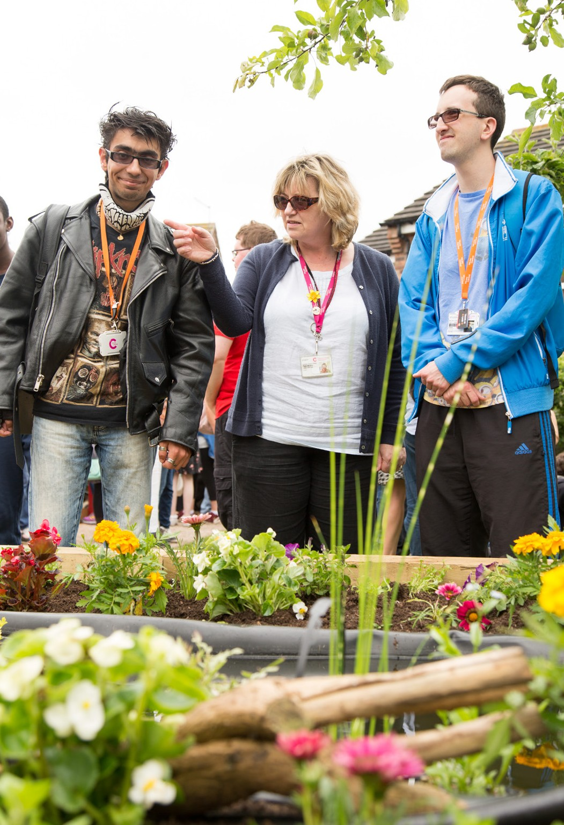learners and apprentices are not fully met”. Continuing to work on these action points gained additional momentum in 2016 and improvements are continually being made as evidenced in observation outcomes.

# 8

1. The EDI Group (Central College Nottingham)

The EDI group at Central College continued to meet regularly (5 times a year) and made significant impact in 2016. Attendance and participation remained good, as did ownership of the EDI agenda. Committee members, representing a broad range of college academic and business areas, worked together to set EDI objectives which are monitored by the EDI advisor.

The EDI group met its terms of reference in 2016 which was to:

* Support the implementation of the Equality and Diversity Policy across the College.
* Monitor the College’s progress towards agreed targets set out in the EDI Action Plan.
* Monitor external developments in equality and diversity including new legislation and new policy initiatives relevant to the FE sector and make recommendations for actions.
* Monitor and evaluate the student data in relation to enrolment, retention, achievement, progression and disciplinary actions by protected characteristics.
* Monitor and evaluate data on the College in relation to applications for College job vacancies, promotion, staff development and disciplinary actions in relation to the protected characteristics.
* Commission and facilitate internal task groups or external consultants to develop specific aspects of equality and diversity work. For example, qualitative research to explore achievement gaps.
* Actively encourage feedback from students, staff and external organisations on any aspects of equal opportunities work.

Key achievements and progress in 2016 include:

* Effective analysis of student data has enabled Qualification Achievement Rates (QAR) trends and concerns to be identified, followed up, and actions put in place to drive improvements. This has contributed towards achievement gaps narrowing or closing, for example between ethnic groups, and the improvement in success rates for students who declare a disability, difficulty or health problem
* Advancing the Prevent Duty and promoting British values to ensure staff and students are aware of their

responsibilities; an online training package was rolled out to all staff and was complemented by face to face sessions and a bank of resources to support academic staff integrate the values into teaching and learning

* Guidance on equality monitoring to increase people’s understanding of the personal information which is requested by the college and to increase disclosure rates for certain groups. For example ESOL students have a disproportionate under disclosure of disability and sexual orientation. Scripts have been made available in other languages and have been circulated to front line services, enrolment and registry teams
* Improvements in learning support for apprentices who disclose a disability, difficulty or health condition through improved disclosure (+3% in 2016 from 2015), staff training and extended support mechanisms
* A Trans and Gender Identity Task and Finish group was set up to review the support for, and experiences of, trans staff and students. Procedures and processes have been reviewed and altered/to be altered to ensure the inclusion of all gender identities – for example the enrolment form led by the ILR to expand gender categories beyond male and female
* As part of the college’s strategy to extend the diversity of the workforce to better reflect the population of Nottingham and the student profile a piece of research on engagement of BAME employees was completed by Human Resources. Resulting recommendations are incorporated into the overall 2016-2020 EDI action plan
* Launch of a sexual harassment campaign at college to challenge everyday sexism and to complement Nottinghamshire Police’s addition of misogyny to hate crime status
* Analysis of staff and student survey results by EDI characteristics to determine levels of satisfaction across groups. This has led to further investigation in the retention and satisfaction of LGB students and resulting actions have been incorporated into the 4 year action plan
* Development of EDI resources for students on an interactive platform (Interact) to complement the online EDI toolkit available for staff
* Achieved level 2 Disability Confident status for the college as a replacement to the two ticks scheme



# 2016 EDI Annual Report

9

1. Staffing Profile

Both colleges aim to collect robust equality data to help identify and address any inequalities. The colleges currently report on the following protected characteristics for established staff: age, gender, ethnicity and disability. The employment journey is mapped from application through to shortlisting and appointment, and then throughout the employee’s work experience (staff training, absence, disciplinary, grievance, and turnover).

Staff equality information is analysed over 3 years. The profiles suggest that whilst there is ongoing work to increase the ethnic diversity of the colleges’ workforce all HR policies and practices continue to reflect good practice in EDI.

Please note: Central’s data was reported on in August 2016. ncn’s data was reported on in December 2016.

Gender profile

Central College Nottingham

In common with the sector, the college’s workforce continues to be predominantly female. Females make up 60% of the workforce with males constituting 40% which is the same as 2015. In terms of gender pay gap reporting, the college has completed some initial work, and in light of the merger aims to publish figures prior to the statutory date (April 2018).

Gender profile by staff group

Despite considerable changes in the workforce in the last four years, including significant downsizing and reshaping of the organisational structure and roles, the gender profile by staff type has remained largely steady. As such the college is confident that the changes have not resulted in a gender imbalance.

The most significant variances are in the management group, however this group is smaller in number and therefore any changes have a greater impact. The balance has swung from a predominantly male management team to a predominantly female one, which is unusual in the sector, although the difference is only 4%.

|  |  |  |  |  |  |  |
| --- | --- | --- | --- | --- | --- | --- |
| Year | Academic Female | Academic Male | Support Female | Support Male | Management Female | Management Male |
| July 12 | 56% | 44% | 67% | 33% | 48% | 52% |
| July 13 | 56% | 44% | 66% | 34% | 47% | 53% |
| July 14 | 56% | 43% | 64% | 36% | 50% | 50% |
| July 15 | 58% | 42% | 64% | 36% | 49% | 51% |
| July 16 | 57% | 43% | 64% | 36% | 52% | 48% |
| Variance | -1% | +1% | = | = | +3% | -3% |



# 2016 EDI Annual Report

10

78% of part-time established staff are female and 22% are male which is the same as 2015. 46% of full-time staff are female, and 54% are male which is the same as 2015.

New College Nottingham

In a similar picture to the sector the college’s workforce continues to be predominantly female. Females make up 67% of the workforce with males constituting 33% which is a small (+1%) increase from 2015.

Gender profile by staff group

Like Central, despite changes in the workforce in the last four years the gender profile by staff type has remained largely consistent. The most significant variances since 2015 are in the academic group which has seen a +2% increase of male staff in the workforce. There continues to be a wide gap between female and male support staff, the latter making up 29% for this staff group.

|  |  |  |  |  |  |  |
| --- | --- | --- | --- | --- | --- | --- |
| Year | Academic Female | Academic Male | Support Female | Support Male | Management Female | Management Male |
| 11-12 | 63% | 37% | 67% | 33% | 58% | 42% |
| 12-13 | 61% | 39% | 68% | 32% | 63% | 37% |
| 13-14 | 63% | 37% | 69% | 31% | 64% | 36% |
| 14-15 | 63% | 37% | 70% | 30% | 67% | 33% |
| 15-16 | 61% | 39% | 71% | 29% | 68% | 32% |
| Variance | -2% | +2% | +1% | -1% | +1% | -1% |

Whilst there has been a year on year increase of part time female staff the percentages for men has remained stable. 39% of the whole staff workforce is made up of part time female staff, compared to 7% of part time men.

Profile of staff who have declared a disability Central College Nottingham

The percentage of employees who have declared a disability has returned to the level of 2014 (7%) which represents a decrease

of 2% from last year. However, the College now has up to date information on all staff in terms of whether they have a declared disability or not, with no ‘unknowns’ reported.

The College remains positive about the employment of people who have a disability and has updated its ‘two-tick’ employer status to the new ‘Disability Confident’ scheme.

73 employees were contacted as part of the 2016 annual review from which 8 requested a review meeting. This resulted in either a referral to Occupational Health or renewing equipment or support. Overall, employees who have declared a disability stated that they are very satisfied with the level of support provided by the College to enable them to undertake their role.

New College Nottingham

The percentage of employees who have declared a disability is consistent with 2015 levels of 6%.

The College remains positive about the employment of people who have a disability and has updated its ‘two-tick’ employer status to the new ‘Disability Confident’ scheme.

Age profile

Central College Nottingham

The age profile remains largely unchanged and is in line with the sector overall.

|  |  |  |  |  |  |  |
| --- | --- | --- | --- | --- | --- | --- |
| Year | 16-25 | 26-35 | 36-45 | 46-55 | 56-60 | 61+ |
| 11/12 | 4% | 19% | 29% | 32% | 11% | 5% |
| 12/13 | 4% | 20% | 28% | 31% | 11% | 6% |
| 13/14 | 4% | 20% | 27% | 33% | 11% | 5% |
| 14/15 | 6% | 19% | 25% | 32% | 12% | 6% |
| 15/16 | 6% | 17% | 24% | 33% | 13% | 7% |
| Variance | = | -2% | -1% | +1% | +1% | -1% |

# 2016 EDI Annual Report

11

In respect of the age profile for full and part time established staff, there are slight differentials (the change from 2014-2015 is shown in brackets) however there are no significant variances between staff groups based on the number of hours worked.

|  |  |  |  |  |  |  |
| --- | --- | --- | --- | --- | --- | --- |
| Group | 16-25 | 26-35 | 36-45 | 46-55 | 56-60 | 61+ |
| Part time | 3% (-2%) | 15% (=) | 24%(-3%) | 39% (+4%) | 13%(+1%) | 6% (+1%) |
| Full time | 9% (+1%) | 19% (-2%) | 23%(+1%) | 29% (-1%) | 12%(=) | 6% (+2%) |

New College Nottingham

The age profile remains largely unchanged and is in line with the sector overall with the largest percentage of employees aged between 46-55

|  |  |  |  |  |  |  |
| --- | --- | --- | --- | --- | --- | --- |
| Year | 16-25 | 26-35 | 36-45 | 46-55 | 56-60 | 61+ |
| 11-12 | 5% | 20% | 29% | 27% | 13% | 6% |
| 12-13 | 5% | 19% | 29% | 28% | 12% | 6% |
| 13-14 | 5% | 19% | 29% | 29% | 11% | 6% |
| 14-15 | 6% | 18% | 28% | 31% | 10% | 7% |
| 15-16 | 7% | 17% | 28% | 31% | 10% | 8% |
| Variance | +1% | -1% | 0% | = | = | +1% |

Ethnicity profile

Central College Nottingham

There has been a +3% increase in Black, Asian and Minority Ethnic (BAME) staff at Central in 2016 from 2015, with 87% of employees classifying themselves as White (White/ English/Welsh/Irish/Any other). This may reflect the continuing work undertaken in Human Resources in 2015/16 to extend the diversity of the workforce to better reflect the population of Nottingham and the student profile.

New College Nottingham

In a similar picture to 2015 the ethnic profile of staff in 2016 has remained steady with 12% of employees identifying as BAME, 85% of employees classify themselves as White (White/ English/Welsh/Irish/Any other) and 3% not known.



# 2016 EDI Annual Report

12

1. Student Profile

The colleges report on the following protected characteristics for students: age, gender, ethnicity, disability, sexual orientation and religion and belief. The student journey is mapped from application to enrolment and once enrolled, includes retention, achievement and overall success. EDI information on students is analysed over 3 years and is benchmarked against national rates. In some instances equality monitoring further extends to cross cut data to explore intersectionality, for example gender and age.

Central’s and ncn’s data was reported on in November 2016. Data shows the student profile for the academic year 2015/2016. In 15/16 achievement rates at Central College were generally affected by pass rates, rather than retention rates which have improved overall by 2% in 15/16. Conversely, at ncn achievement rates have benefited from an improvement in pass rates (+2%) compared to retention rates which have fallen -1% from 14/15.

Please note: Where any imbalance in the student profile occur actions to investigate and targets to remedy any gaps are incorporated into the EDI 4 year action plan, 2016-2020 or locally managed annual curriculum plans.

Gender profile

Central College Nottingham

In 2015/16 54% of students on courses were female, the same percentage as 14/15. This largely reflects the gender split in the county with 51% female and 49% of the population of Nottinghamshire male. The gender split has narrowed since 13-14 (56% female).

In a similar picture to 14/15 there is a small differential between genders with student retention, pass and achievement rates, with females +2% ahead of males in overall achievement.

Achievement rates for males have fallen -4% since 14/15 though retention rates have improved +4% for this group of students (now

+1% above national rate).

|  |  |  |  |  |  |  |  |  |  |  |  |  |
| --- | --- | --- | --- | --- | --- | --- | --- | --- | --- | --- | --- | --- |
|  | Retention | | | | Pass | | | | Achievement | | | |
|  | 13/14 | 14/15 | 15/16 | Nat Rate | 13/14 | 14/15 | 15/16 | Nat Rate | 13/14 | 14/15 | 15/16 | Nat Rate |
| Female | 91% | 91% | 92% | 92% | 94% | 92% | 92% | 91% | 85% | 85% | 84% | 84% |
| Male | 91% | 89% | 93% | 92% | 91% | 93% | 89% | 91% | 82% | 83% | 82% | 83% |
| Total | 91% | 90% | 92% | 92% | 92% | 93% | 90% | 91% | 83% | 84% | 83% | 84% |

Gaps have closed between gender and age groups, since 14/15. Differentials occur with 16-18 year old female achievement rates falling 7% below the overall college average, and 3% below males (in 14/15, 10% below college overall achievement rates and 7% behind males).

19+ females achieve 4% above college SSR and 19+ males are now at national rate and just 1% behind females.

New College Nottingham

In 2015/16 67% of students on courses were female, which reflects a higher percentage than county figures (51% female). The percentage of 16-18 female students (54%) more closely reflects Nottinghamshire’s picture and it is the 19+ students who are largely female (75%).

In a similar picture to 14/15 there is a differential between genders with student retention, pass and achievement rates, with females +4% ahead of males in overall achievement.

Achievement rates for males have remained stable since 14/15 though pass rates have improved +2% for this group of students (now +2% above national rate).

|  |  |  |  |  |  |  |  |  |  |  |  |  |
| --- | --- | --- | --- | --- | --- | --- | --- | --- | --- | --- | --- | --- |
|  | Retention | | | | Pass | | | | Achievement | | | |
|  | 13/14 | 14/15 | 15/16 | Nat Rate | 13/14 | 14/15 | 15/16 | Nat Rate | 13/14 | 14/15 | 15/16 | Nat Rate |
| Female | 92% | 93% | 92% | 92% | 92% | 93% | 95% | 91% | 85% | 87% | 88% | 84% |
| Male | 92% | 93% | 90% | 92% | 90% | 91% | 93% | 91% | 83% | 84% | 84% | 83% |
| Grand Total | 92% | 93% | 92% | 92% | 92% | 92% | 94% | 91% | 84% | 86% | 86% | 84% |

# 2016 EDI Annual Report

13

Disability Profile

Central College Nottingham

There has been a further +1% increase in students who disclose a disability, difficulty or health condition with the figure now at 30% (a +9% increase from 2013/2014). 0.5% of students did not provide any information in response to this question.

Achievement rates for students who declare a disability, difficulty or health problem is 1% higher than the college average and those who have no disability, although falls -1% short of national rate. The +5% gap from 14/15 in favour of those with a disability has closed in 15/16.

Those who declare a disability, difficulty or health problem have the poorest achievement rates for Basic Skills, Maths and English qualifications.

Achievement rates where “no information has been provided” have remained stable.

The increase in numbers of students disclosing a mental health condition has continued in 15/16 with 7% of all students now recorded. Students with a disclosed mental health condition have seen an improvement in retention rates in 15/16 (+4% above college average) and have overall achievement rates +9% above college average.

The percentage of students disclosing a disability (6%) is disproportionate for those on ESOL qualifications. For these qualifications students with no disabilities have +6% higher achievement rates than those who declare a disability, difficulty and health condition.

New College Nottingham

9% of students in 2015/16 declared a disability, difficulty or health condition, with 91% stating they have no disability.

Achievement rates for students who declare a disability are 2% lower than those who do not. Pass rates are on par for both groups (disabled students have consistently improved their pass rates since 13/14) and it is retention which adversely affects overall achievement for students with a disability.

Ethnicity Profile

Central College Nottingham

In a similar picture to 2015, in 2016 61% of students were White British with 26% of students from Black and Minority Ethnic (BAME) groups, 11% Other White and 2% Not Provided. The BAME profile in 15-16 remained the same as previous years despite a drop in the overall number of enrolments.

The table below shows the profile for the main Black, Asian and Minority Ethnic (BAME) groups.

|  |  |  |  |  |  |
| --- | --- | --- | --- | --- | --- |
| Ethnic Group Representation of Total Population % | | | | | |
| Ethnic Group | College students 2012-2013 | College students 2013-2014 | College students 2014-2015 | College students 2015-2016 | Census 2011 Nottingham Population |
| African | 4.2% | 4.7% | 6.4% | 7.3% | 3.2% |
| Arab | 0.3% | 0.4% | 0.6% | 0.8% | 0.8% |
| Bangladeshi | 0.4% | 0.4% | 0.3% | 0.4% | 0.3% |
| Caribbean | 2.7% | 2.5% | 2.9% | 2.2% | 3.1% |
| Chinese | 0.5% | 0.6% | 0.7% | 0.6% | 2.0% |
| Indian | 1.6% | 1.4% | 1.5% | 1.5% | 3.2% |
| Pakistani | 3.3% | 3.3% | 4.0% | 3.7% | 5.5% |
| Other Asian | 2.2% | 2.5% | 3.1% | 2.9% | 2.0% |
| Other Black | 0.9% | 0.8% | 1.3% | 1.0% | 1.0% |
| White/Black Caribbean | 2.2% | 2.5% | 2.3% | 2.3% | 4.0% |

The overall achievement gap between ethnic groups from 14/15 widened with Other White and Gypsy/Irish Traveller having the highest and lowest rates respectively, although small numbers have adversely affected percentages for the latter group.

White/Black Caribbean, White/Black African and Arab students all have rates which fall below college and national rate over a 3 year period. In 15/16 Other Asian, Other Black, Pakistani and Other Mixed students are also highlighted.

There have been improvements in retention across 11 ethnic groups. Retention for African, Caribbean and White/Black Caribbean students, highlighted as areas for improvement in 14/15, have improved +5%, +6% and +1% respectively.

# 2016 EDI Annual Report

14

New College Nottingham

In a similar picture to 2015, in 2016 66% of students were White British with 27% of students from Black and Minority Ethnic (BAME) groups, 7% Other White with 0.3% Not Provided.

The overall achievement gap between ethnic groups from 14/15 has narrowed by 5% with Gypsy/Irish Traveller (100%) and Irish (79%) and White/Black Caribbean (79%) having the highest and lowest rates respectively.

White/Black Caribbean, White/Black African and Irish students all have rates which fall below college and national rate over a 3 year period. In 15/16 Other, Other Mixed, Caribbean and Pakistani students are also highlighted. There were improvements in pass rates for 13 ethnic groups in 15/16.

Sexual Orientation profile Central College Nottingham

Disclosed lesbian, gay and bisexual (LGB) students make up just 3% of the student population (+1% from 14/15) which is not

reflective of the national population. 37% of students have either opted for the ‘prefer not say’ option or have not answered this question (29% in 14/15).

LGB students continue to have achievement rates which fall short of the college average. There is an 18% differential in achievement between the highest rates for the group of students who did not answer the question and the lowest rates for students who identify as gay, the latter group falls 10% below college average. However small numbers have in most cases adversely affected rates.

New College Nottingham

In the same picture as 2014/2015 disclosed lesbian, gay and bisexual (LGB) students make up just 2% of the student population which is not reflective of the national population. 47% of students have either opted for the ‘prefer not say’ option or have not answered this question (44% in 14/15).

LGB students continue to have achievement rates which fall short of the college average. There is an 11% differential in achievement between the highest rates for the group of students who did not answer the question and the lowest rates for students who identify as bisexual, the latter group falls 8% below college average. Rates have however improved significantly from 14/15,

+10% for bisexual students and +7% for gay and lesbian students.

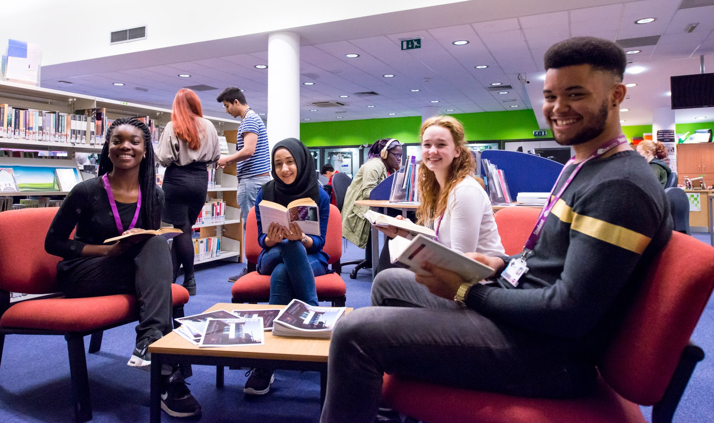

# 2016 EDI Annual Report

15

Age profile

Central College Nottingham

In 2015/2016 36% of students were aged 16-18. This is an increase on 14/15’s and 13/14’s percentages of 32% and 30% respectively. 64% of students were aged 19+, representing a 4% drop from 14/15 and 5% from 13/14.

The disparity in achievement rates (9%) between age groups is on par with 14/15 which saw a closure of the gap from 11% in 13/14. 16-18 student rates are affected by both retention and pass rates. Retention is at national rate and pass rates are -2% below national average. Rates for 19+ students are well above college average (+4%) and national rate (+2%).

|  |  |  |  |  |  |  |  |  |  |  |  |  |
| --- | --- | --- | --- | --- | --- | --- | --- | --- | --- | --- | --- | --- |
|  | Retention % | | | | Pass % | | | | Achievement % | | | |
|  | 13/14 | 14/15 | 15/16 | NR | 13/14 | 14/15 | 15/16 | NR | 13/14 | 14/15 | 15/16 | NR |
| 16-18 | 88% | 88% | 90% | 90% | 88% | 90% | 92% | 89% | 80% | 83% | 83% | 81% |
| 19+ | 92% | 92% | 94% | 93% | 95% | 95% | 96% | 92% | 87% | 88% | 89% | 85% |
| Total | 91% | 90% | 92% | 92% | 92% | 92% | 94% | 91% | 84% | 86% | 86% | 84% |

New College Nottingham

In 2015/2016 49% of students were aged 16-18. This is an increase on 14/15’s and 13/14’s percentages of 47% and 46% respectively. 51% of students were aged 19+.

The disparity in achievement rates (6%) between age groups has widened since 14/15 (5%). 16-18 student rates however are +2% above national rate which reflects the improvement in pass rates for this group. Rates for 19+ students are well above college and national average (+4%).

|  |  |  |  |  |  |  |  |  |  |  |  |  |
| --- | --- | --- | --- | --- | --- | --- | --- | --- | --- | --- | --- | --- |
|  | Retention % | | | | Pass % | | | | Achievement % | | | |
|  | 13/14 | 14/15 | 15/16 | NR | 13/14 | 14/15 | 15/16 | NR | 13/14 | 14/15 | 15/16 | NR |
| 16-18 | 91% | 93% | 90% | 90% | 88% | 90% | 92% | 89% | 80% | 83% | 83% | 81% |
| 19+ | 92% | 93% | 92% | 93% | 95% | 95% | 96% | 92% | 87% | 88% | 89% | 85% |
| Total | 92% | 93% | 92% | 92% | 92% | 92% | 94% | 91% | 84% | 86% | 86% | 84% |

Religion and Belief profile

Central College Nottingham

In 15/16 28% of students who disclosed their religion or belief identified as Christian, a -6% drop from 14/15. There has however been an increase (+9% from 14/15) in those students who either did not answer this question or selected to “prefer not to say” (30% in 15/16.). Atheist students are recorded as the second largest group at college (22%) followed by Muslim students (8%) and Agnostic students (6%).

There is a 17% differential in achievement (+2% since 14/15) between the highest rates for Jewish students and the lowest rates for Muslim and Atheist, as well as Buddhist students. This reflects a very similar picture to 14/15 for the two former groups. In 15/16 however achievement rates for these students are affected by pass, rather than retention, rates in line with the college’s overall picture. Small numbers in many groups adversely affect percentages for example only 14 Jewish and 80 Buddhist (compared to for example 4359 Atheist learners).

New College Nottingham

In 15/16 15% of students who disclosed their religion or belief (including no religion or belief) identified as Christian/Catholic, the same percentage as 14/15. 64% of students did not want to disclose their religion or did not answer this question.

Atheist students are recorded as the second largest group at college (13%) followed by Muslim/Islamic students (6%).

There is a 19% differential in achievement (+1% since 14/15) between the highest rates for Jewish students and the lowest rates for those who selected ‘Islam’. This reflects a similar picture to 14/15 for these groups. In 15/16 however achievement rates for these students are affected by pass, rather than retention. Small numbers in many groups adversely affect percentages for example only 6 Jewish students enrolled.

# 2016 EDI Annual Report

16

1. EDI Actions in 2016

In 2016, the colleges continued to raise awareness of EDI matters, maintain legislative compliance and, using

collaborative working strategies, engage and develop staff and students to advance equality, eliminate discrimination and celebrate diversity.

The EDI advisor and the advanced practitioners at ncn and Central worked collaboratively with staff at all levels and in all role types, to strengthen the skills and confidence of teachers to embrace and embed EDI in teaching and learning.

The EDI advisor at Central continued to be receptive to a wide range of enquiries in response, in many instances, to changing circumstances, for example providing advice and guidance on trans issues in light of an increase in disclosures; balancing safeguarding and security and cultural and religious needs

for example; exploring the integration of British values into all aspects of college life; research into trans identities to ensure inclusivity of all genders.

This work has included:

1. Policy Development

An EDI policy drafted for the new merger college.

A new shared Equality Analysis template and procedure for the new college.

Reviewed statement in the purchase order terms and conditions to ensure any contractors are fulfilling their EDI responsibilities as well as adhering to the Modern Slavery Act.

1. Promoting EDI

EDI continued to be promoted at every level. The VP for Organisational Development at Central and the Director for Human Resources led on the EDI agenda at their respective colleges to ensure that equality, diversity and inclusion is integrated into all functions.

EDI matters continue to be communicated through a range of media, including electronically; internally via the intranet,

Moodle and SharePoint and externally via the website and EDI Facebook page at Central. Posts involve sharing news stories, resources and promoting events to increase engagement

and participation. 2016 has seen an increased usage of all platforms.

Noticeboards promoting the EDI agenda are updated at all sites and contain up to date and relevant information on EDI and

anti-bullying. Diversity calendars, which support a variety of cultural and charitable events locally and nationally, continue to be popular and are available online and in hard copy and are displayed at key service points.

An array of campaigns which promote respect and tolerance and focus on student’s personal wellbeing and development were embraced by ncn’s Student Union (see iii. Engaging Students).

A British Values poster competition initiated by a student EDI rep at Central saw the winning designs used across college sites in 2016 to promote mutual respect and tolerance, individual liberty, democracy and the rule of law.

A sexual harassment campaign involving a range of posters, resources and workshops, on request, was launched at Central.

The EDI agenda is well represented outside of college with participation on the Nottinghamshire Police LGBT

Advisory Committee, Diversity and Inclusion HR Network for Nottingham and the Journeys to Justice Committee.

1. Engaging Students

In 2016 students have been involved in a wide range of activities to celebrate diversity, challenge perceptions and increase awareness and understanding of others as well as British values, particularly Mutual Respect and Tolerance, Individual Liberty and Democracy.

Examples include:

* ADHD awareness raising event to challenge assumptions
* Caribbean Heritage event with pop up exhibitions
* Catalyst, a young leadership course delivered by St Philips Centre
* Dyslexia & Dyspraxia Awareness Week - myths and facts campaign
* Deaf Awareness activities including bitesize BSL sessions
* LGBT Lace up campaign challenging homophobia, biphobia & transphobia in sport
* Human Rights Day campaign to ‘stand up for someone’s rights today’
* IDAHO – International Day Against Homophobia artwork campaign
* International Day of Happiness poster campaign to raise awareness of mental health
* ‘International Tea and Talk’ for International Students’ day
* International Men’s Day and International Women’s Day activities
* Inter faith exhibition and workshops for national interfaith week
* Movember – Men’s Health Awareness Month
* National Stress Awareness Day with pledges for a theme of ‘kindness’
* Register to Vote event in preparation for EU referendum
* World Religion Day activities to promote interfaith understanding

# 2016 EDI Annual Report

17

A total number of 662 students at Central were engaged in these activities across college sites and across curriculum areas with positive impact:

*“This is a fantastic event and it has opened my eyes to how difficult it must have been for many of these people when immigrating over to a new country. Only being able to take one suitcase with them into the unknown, being told that they would be welcomed with open arms, to end up being rejected and face animosity from others.”* - Student at Caribbean Heritage event

*“Participants reported an increased sense of community cohesion with an improved understanding of difference, in particular different faiths and beliefs”.* - Staff member on Catalyst participation

A range of teaching and learning sessions for students which were tailored to vocational areas were delivered to inform understanding of equality, diversity and effective practice (38 sessions with 618 students). An EDI section on Interact was developed to provide online access to resources and in 2016 1152 students accessed Central’s online EDI tutorial as part of their induction.

At ncn students scripted a promotional film highlighting the key values around EDI, outlining expectations around respect and tolerance for others as well as promoting multi faith rooms on college sites. The film served as part of students’ induction.

Students worked together in student partnership events aimed at breaking down barriers between diverse groups of students. This included for example, international students participating in on-the-job training sessions delivered by Construction students.

The EDI agenda is well represented on student forums, Student Union and student council meetings through the Student Voice Coordinator, EDI officer and Vice Principal for Organisational Development. The Student Union Secretary at ncn was designated as the Student Prevent Lead. The bespoke role embraced learner leadership in relation to ‘Staying Safe’ and promoting inclusion. It focused on bringing the diverse student and staff body together to raise awareness of extremism and radicalisation. All the ncn Student Executive team engaged

in WRAP training (Workshop to Raise Awareness of Prevent) alongside ncn staff teams to broaden their understanding of the government agenda, and develop skills and knowledge to support the college wide strategy.

The 2016 Students’ Union elections saw the introduction of a bespoke ‘Women’s Officer’ role on the SU Executive at ncn. The role’s focus is on issues affecting the college’s female members including welfare, equality and education. Particular focus was on women’s engagement in student leadership, societies and extra-curricular activities including the college’s sports programme.

A full calendar of sport enrichment activities was promoted through induction and the student brochures which features key themes underpinning health, wellbeing, and personal development. Activities continue to be inclusive and aim to increase participation in underrepresented groups, for example Boccia, and female football.

Less formal opportunities continued to be exploited to communicate with students on EDI matters to ensure the EDI agenda maintained a high profile around college.

1. Training and Development

A wide range of training opportunities for academic and support areas on EDI themes designed to improve knowledge, practice and outcomes for students were offered as online learning courses or face to face delivered sessions. A key focus was to work collaboratively with academic staff to advance understanding of EDI duties and to strengthen skills and confidence in embedding EDI in teaching and learning. Actions included:

* Review of Self-Assessment Reports, QAR data trends and observation reports to identify training needs across business and curriculum areas on a range of subjects
* Termly meetings with Heads of Academy at ncn which allowed planning for highly effective professional development, as well as helping less effective teachers improve
* Robust developmental analysis of training needs for each member of teaching staff through ncn’s observation process
* Delivery of one to one, small group and whole team coaching/support/training to both staff and students at Central
* Sharing of good practice through contributions to the online EDI toolkit which has advanced understanding of individuals’ EDI duties ; and strengthened abilities and confidence to embed EDI in teaching and learning at Central
* Utilisation of the diversity planner which has become the go-to document for schemes of work, themed tutorials and the ‘Awareness Raising’ calendar at ncn
* E-learning mandatory modules (Safety Media or bespoke packages) for new staff to ensure 100% of employees have undertaken the EDI introductory courses at ncn

In 2016 at Central formal face to face training was delivered to 248 staff members including work place assessors, International Foundation, ESOL, front line administrators, student finance administrators, Automotive, Horizons, Construction, Business ER, Engineering, Sport and Public Services, Additional Learning Support, external training providers (Partnerships) and a cohort of new teachers.

Sessions included: Integrating EDI in Work Place Learning; Integrating EDI in Teaching, Learning and Assessment, Black Coffee v White Coffee; Disability Equality, Immigration Explored, Promoting Sexual Orientation Diversity, New Teachers Induction, British Values, Creating Cohesive Environments and Integrating EDI in Planning.

In addition to these formal sessions a number of 1:1 support sessions were held, for example to discuss specifically the barriers teachers face in promoting diversity in the classroom; or with an external training provider to conduct an EDI health check on their provision for students.

# 2016 EDI Annual Report

18

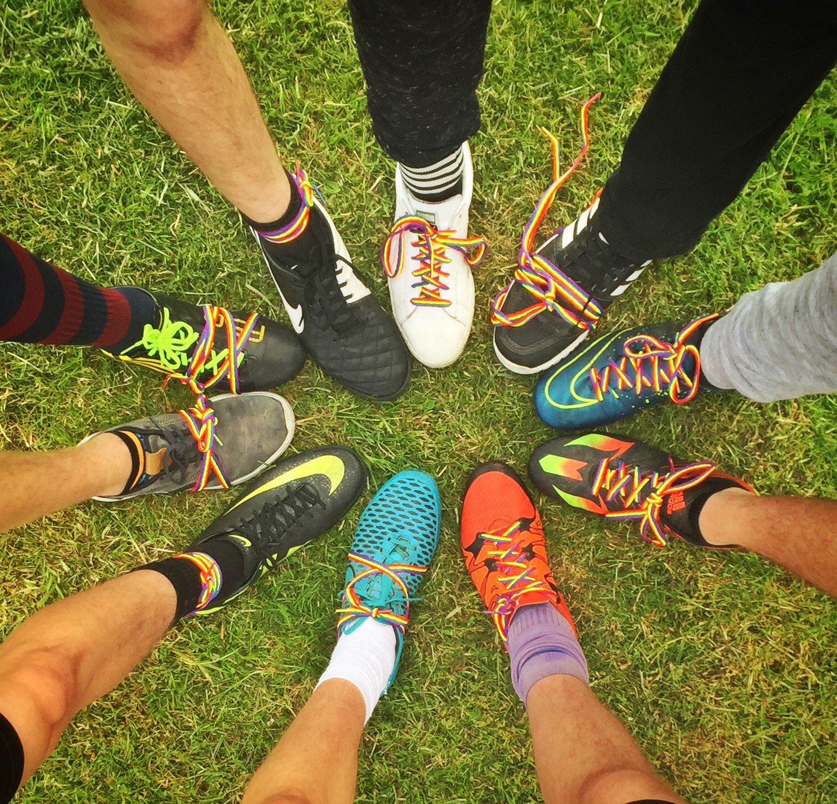

In 2016 at ncn 467 members of staff participated in a broad range of EDI training, 274 academic staff receiving specific training on embedding equality and diversity in the curriculum; 28 nominated staff participated in Train the Trainer workshops to become their team’s go to expert and the Tutorial Development Officer continued to expand their knowledge of embedding fundamental British Values to support the tutorial programme.

The 2016 Staff Development Festival promoted inclusivity of engagement for all ncn staff as for the first time with every campus closed, to encourage participation, with the exception of City, the host site. This afforded Cleaning teams, Campus Management staff and Nursery colleagues the opportunity to access the event.

A British Values mandatory training module, launched in the autumn term of 2015, was completed by 302 Central staff who were introduced to the duty, and increased awareness of how the values are practically embedded into college life

In 2016 38 teaching sessions were delivered for 618 Central students. 54% of the 618 students who received training were on level 3 courses, with the next largest group of students

on level 2 courses (27%). Students were from 10 different curriculum areas. Sessions were delivered on the request of curriculum staff and included: An Introduction to Equality, Diversity and Inclusion; Equality and Effective Practice; Diversity and Community; Immigration, Myths and Facts; Discrimination and Harassment and British Values. In 15-16 a further 1152 students accessed the online EDI tutorial as part of their induction.

Training evaluation evidenced that 97% of those students who completed a feedback form (583) and 100% of staff (187) said that training was good or better overall; and that their knowledge and confidence had improved as a result.

Evidence of progress made with regard to embedding EDI in teaching and learning can be found in lesson observation

reports. 430 observations and 10 specific EDI learning walks were undertaken in 15/16 at Central. Key themes are as follows:

* Very good levels of respect are present in most classrooms
* Good individual and group support is available and students are supportive of each other in the main
* The learning environment is well suited to the needs of most students
* The environment is inclusive and welcoming
* Levels of differentiation are not always consistent
* Inappropriate language and/or behaviour is not always challenged
* Planning for integration of EDI is not always evident e.g. in Schemes of Work
* Very good visible promotion of EDI in learning environments in the main
* Students are both supported and challenged in the main
* Promotion of diversity is sound and effective more often than not
* Fewer opportunities to promote diversity are missed
* Students demonstrate a very good understanding of EDI. Observers have noted improvements in students’ understanding from 2014-15
* Good links to British values are made in curriculum content and through naturally occurring opportunities

There are a good range of statements from Teaching and Learning Coaches to evidence improvement in the promotion of diversity in the classroom, for example:

* *“Targets were pertinent to individual learners and differentiated tutor support enabled learners to learn in a way that was appropriate to them individually”*
* *“Students collaborated extremely well and worked with enthusiasm and a real sense of purpose. Students also had respect for each other’s opinions, experiences and dietary preferences and this resulted in an environment which respected difference and embraced diversity.”*

Evidence of progress made with regard to embedding EDI in teaching and learning at ncn can be found in lesson observation reports. 344 observations and a learning walk review week on embedding E&D lead to the following outcomes:

* Very good levels of respect are present in most classrooms
* Learners receive and give high levels of support to each other during learning sessions and this is supported through teachers planning opportunities for learners to work with peers
* ‘Classrooms are well equipped and learners benefit from good physical resources that support their learning effectively’ (Ofsted, 2016)

# 2016 EDI Annual Report

19

* The college is welcoming and learners feel safe, demonstrating the inclusive environment
* Differentiation is improving in many areas, but is not consistent
* Inappropriate language and/or behaviour is always challenged and all staff have been trained to challenge and report
* Planning to embed EDI awareness in teaching and learning has improved as a direct result of EDI training
* There is an inconsistent approach to the promotion of EDI materials across curriculum areas
* Learners are supported to develop and challenge within and outside the curriculum to ensure the college is learner-led and therefore fulfilling PDBW obligations
* British Values development and embedding is still in its infancy and staff require further support

1. Service Monitoring

At Central, where there is a specialist EDI advisor, the service standards as detailed in the EDI Service Level Agreement were met and in most cases exceeded. The Service Standards are:

* To acknowledge requests for EDI training within 48 hours of receipt and offer options to receive training within 5 working days
* 100% of face to face EDI training is evaluated by participants as being good or better overall
* To acknowledge telephone, e-mail or written enquiries on EDI matters within 24 hours and to provide a response to the enquiry within 2 working days

Key Performance Indicators monitor student and staff satisfaction as well as the impact of EDI training and the EDI team works closely with the College MIS team to regularly review and report on data trends which are examined as part of the College’s performance monitoring process.

EDI data dashboards are presented at EDI group meetings to inform target setting, objectives and actions. Complaints are included.

Student surveys are analysed to monitor the impact of staff training to embed EDI into the curriculum as well as the effectiveness of EDI initiatives to create a culture of respect. Staff surveys are analysed to monitor satisfaction and general impact of the EDI agenda, that is, a safe, respectful and fair place to work.

1. Incidences of Bullying and Harassment

The colleges have a zero tolerance approach to bullying and harassment, which includes sexism, racism, homophobia and any other form of offensive behaviour, deliberate or not.

A merged Harassment and Bullying Policy (including an easy read version) exists for staff and students. In 2016 all

managers at Central had completed harassment and bullying training. The exploration of inappropriate language and behaviour has been a key feature of staff and student EDI sessions.

Procedures for dealing with any incidents and complaints are followed and outcomes are recorded. Formal complaints are categorised according to EDI characteristics and the nature of the complaint (discrimination/harassment) and are then reviewed by the EDI group. At Central 2016 saw a reduction in both the overall number of complaints and the number of complaints substantiated (only 1 in 15/16).

# 2016 EDI Annual Report

20

Appendix A

Guidance on the Public Sector Equality Duty, 2011

The Public Sector Equality Duty is made up of a General Equality Duty which is supported by Specific Duties.

The General Equality Duty requires public authorities, in the exercise of their functions, to have due regard to the need to:

* Eliminate discrimination, harassment and victimisation and any other conduct that is prohibited by or under the Equality Act 2010
* Advance equality of opportunity between people who share a relevant protected characteristic and people who do not share it
* Foster good relations between people who share a relevant protected characteristic and those who do not share it

Public authorities, including Central College Nottingham, listed in Schedule 1 and 2 of The Equality Act 2010 (Specific Duties) Regulations 2011 (the specific duties) are required to show functional transparency by:

* Preparing and publishing one or more equality objectives which can be achieved to do any of the things mentioned in the aims of the General Equality Duty, by 6 April 2012 and at least every four years thereafter
* Ensuring that those equality objectives are specific and measurable
* Publishing those equality objectives in such a manner that they are accessible to the public



# 2016 EDI Annual Report

21

2016 EDI Annual Report

22

2016 EDI Annual Report

23

2016 EDI Annual Report

1617 0140

24