

**Equality, Diversity**

**and Inclusion Policy**

**Easy Read Version**

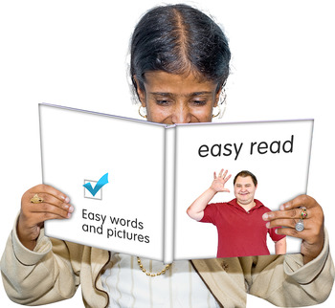

**Contents (what you will read about)**

**Page**

Introduction 3

What the College says 4

The Law 5

Who is the law for? 5

Different types of discrimination 8

Treating disabled people fairly 11

Who has to stick to the law? 12

What the College will do? 13

How to contact us? 17

**Introduction**

The **Equality, Diversity and Inclusion** policy sets out what the College will do.

It follows the **Equality Act 2010** and the **Public Sector Duty.**

The policy applies to everyone at College: students, staff, visitors, parents and people who come into College to do work.

**Equality =** this means treating everyone fairly. It means making sure everyone gets the help they need to have the same chances to do what they can.

**Diversity =** This is a mix of different kinds of people. For example, men and women, young and old people, people of different races, disabled and non-disabled people.

**Inclusion =** this means that everyone is included in all parts of College life.

**What the College says**



Everyone has the right to be treated with respect.

Everyone has the right to be treated fairly.

Everyone should be included

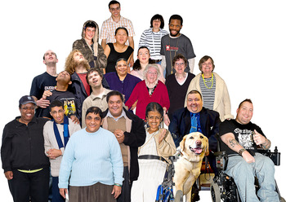

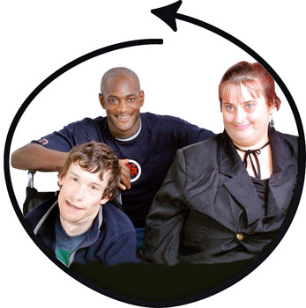

**What the law says**

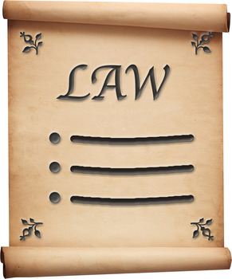

The **Equality Act 2010** is the Government’s law to make sure all people are treated fairly. The Equality Act is for everyone.

The law talks about different

**protected characteristics** or things to do with a person:

* Age
* Disability

The College has to make sure that everyone has an opportunity to learn.

**Duties**

These are things the law says someone must do.

We will tell you what the course is about and what you need to do to join a course.

We will tell you how you will be taught, how you will learn and how you will be assessed.

**Who is the law for?**

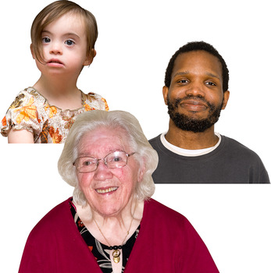

The law talks about different

**protected characteristics** or things to do with a person:

* Age
* Disability

The College has to make sure that everyone has an opportunity to learn.

**Duties**

These are things the law says someone must do.

We will tell you what the course is about and what you need to do to join a course.

We will tell you how you will be taught, how you will learn and how you will be assessed.





* Gender (if they are a man or a woman)
* Transgender people.

These are people who feel that the body they were born into is not right for them. This means they may want to change from being a man to a woman, or from a woman to a man.

* Being pregnant or having a baby







* Race
* Religion or Belief
* Sexual Orientation (being straight, gay, lesbian or bisexual)





**Different types of discrimination**

The Equality Act protects people in these groups from discrimination.

**Discrimination** means treating someone worse than other people for some reason.

**Direct Discrimination** is when an organisation or service treats someone worse than other people.









**Discrimination by Association** is when a service or organisation treats someone worse than other people because of someone they know.

**Discrimination by perception** is when a service or organisation treats someone unfairly because they think they are from a particular group.

**Indirect discrimination** is when a service or organisation does something, decides something, or has a rule that affects some people worse than others.







**Discrimination arising from a**

**Disability** is when a service or

organisation treats someone unfairly because of something to do with their disability.

**Harassment** means picking on

someone or upsetting them on

purpose.

**Victimisation** is when a service or

organisation treats someone unfairly because they have complained or spoken up about something.





**Treating disabled people fairly**

The law says that organisations and services have to think about what people with different disabilities might need.

**Reasonable adjustments** are changes that individuals and organisations must make to give a person who is disabled the same chance as anyone else to use a service.

**Reasonable** means something that is fair and that an organisation is able to do.





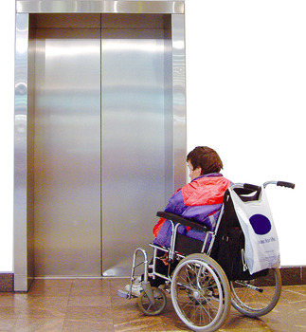

**Who has to stick to the law?**

People or organisations that provide

services must stick to the law and treat everyone fairly.

Public services and people who work for them must stick to the law and make sure everyone has an equal chance to use their service.

At the College there is a team of staff who work to make sure these things happen.

improve. We will review personal action plans to help you achieve your potential.

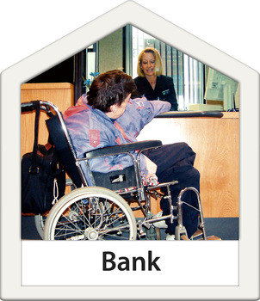



**Public**

**Sector**

**Duty**



**What the College will do**

The College will make sure its staff know how important it is to treat everyone fairly and not to discriminate.

The College will make sure it treats everyone fairly and does not discriminate when it is making any plans or rules.

The College will make sure that its buildings and services can be used by anyone.

improve. We will review personal action plans to help you achieve your potential.









The College will challenge any discrimination, harassment or victimisation.

The College will work with students, parents and community groups to stop discrimination and harassment.

The College will think about what different people might need.

You can complain about things the College has done or not done.

improve. We will review personal action plans to help you achieve your potential.

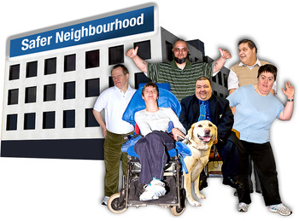



The College will look at the different types of learners and staff in the organisation to make sure everyone has a fair chance to succeed.

The College might sometimes provide special services or give some groups of people information or training. This is known as **Positive Action.**

For example, the College may provide more support to disabled people than people who do not have a disability if this helps them learn.

You can complain about things the College has done or not done.

improve. We will review personal action plans to help you achieve your potential.







The College will create an Action Plan to make sure all these things happen.

The Action Plan will be looked at to make sure the College is on track.

If you are not happy you can complain about things the College has done or not done.

improve. We will review personal action plans to help you achieve your potential.

Action Plan





Action Plan



**How to Contact Us**



Telephone **0115 8842817**



inclusion@centralnottingham.ac.uk

**For more information**

[Click here](https://www.gov.uk/government/uploads/system/uploads/attachment_data/file/85012/easy-read.pdf?view=Binary)

The Equality Act, making equality real. Easy read version; Government Equalities office.



[Click here](http://www.equalityhumanrights.com/uploaded_files/EqualityAct/equality_act_2010_services_easyread.pdf)

A Guide to the Equality Act. Easy read version by the Equality and Human Rights Commission.